**Practical No.26**

**Aim:** To create a blur effect on picture using flash animation

**Performed by**: Parth Khichi

**Class:** BCAIII SEM-V

**Date:** 15/10/2024

**Image :**

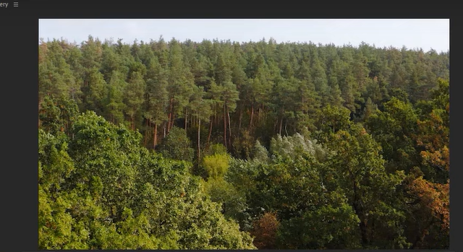

**Output :**

